**CS 255 System Design Document Template**

This template lays out all the different sections that you need to complete for Project Two. Each section has guidance to prompt your thinking. You will need to continually reference the interview transcript as you work to make sure that you are addressing your client’s needs. There is no required length for the final document. Instead the goal is to complete each section based on what your client’s needs are. Remove this note when you are finished, and replace all bracketed text with the relevant information.

**UML Diagrams**

**UML Use Case Diagram**

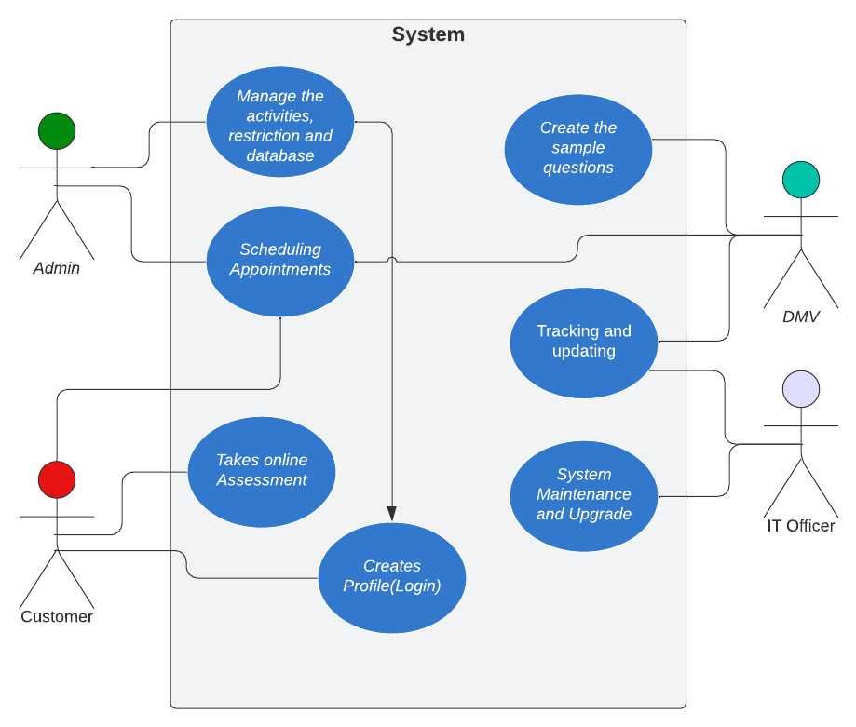

**UML Activity Diagrams**

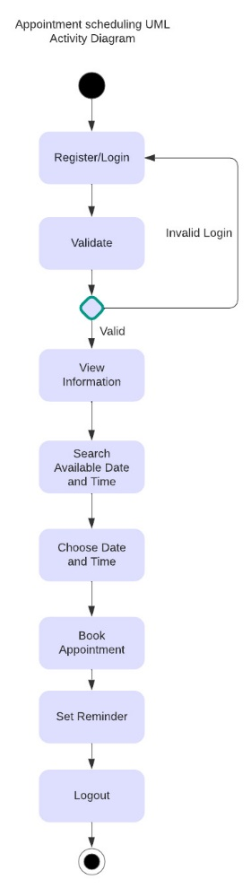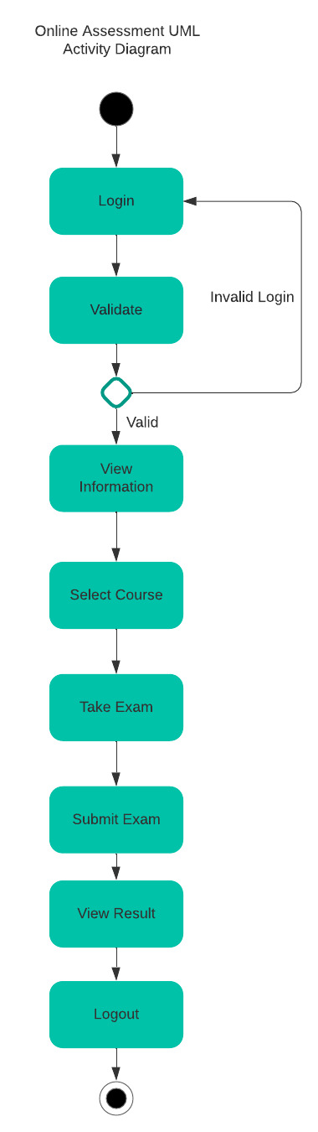

**UML Sequence Diagram**

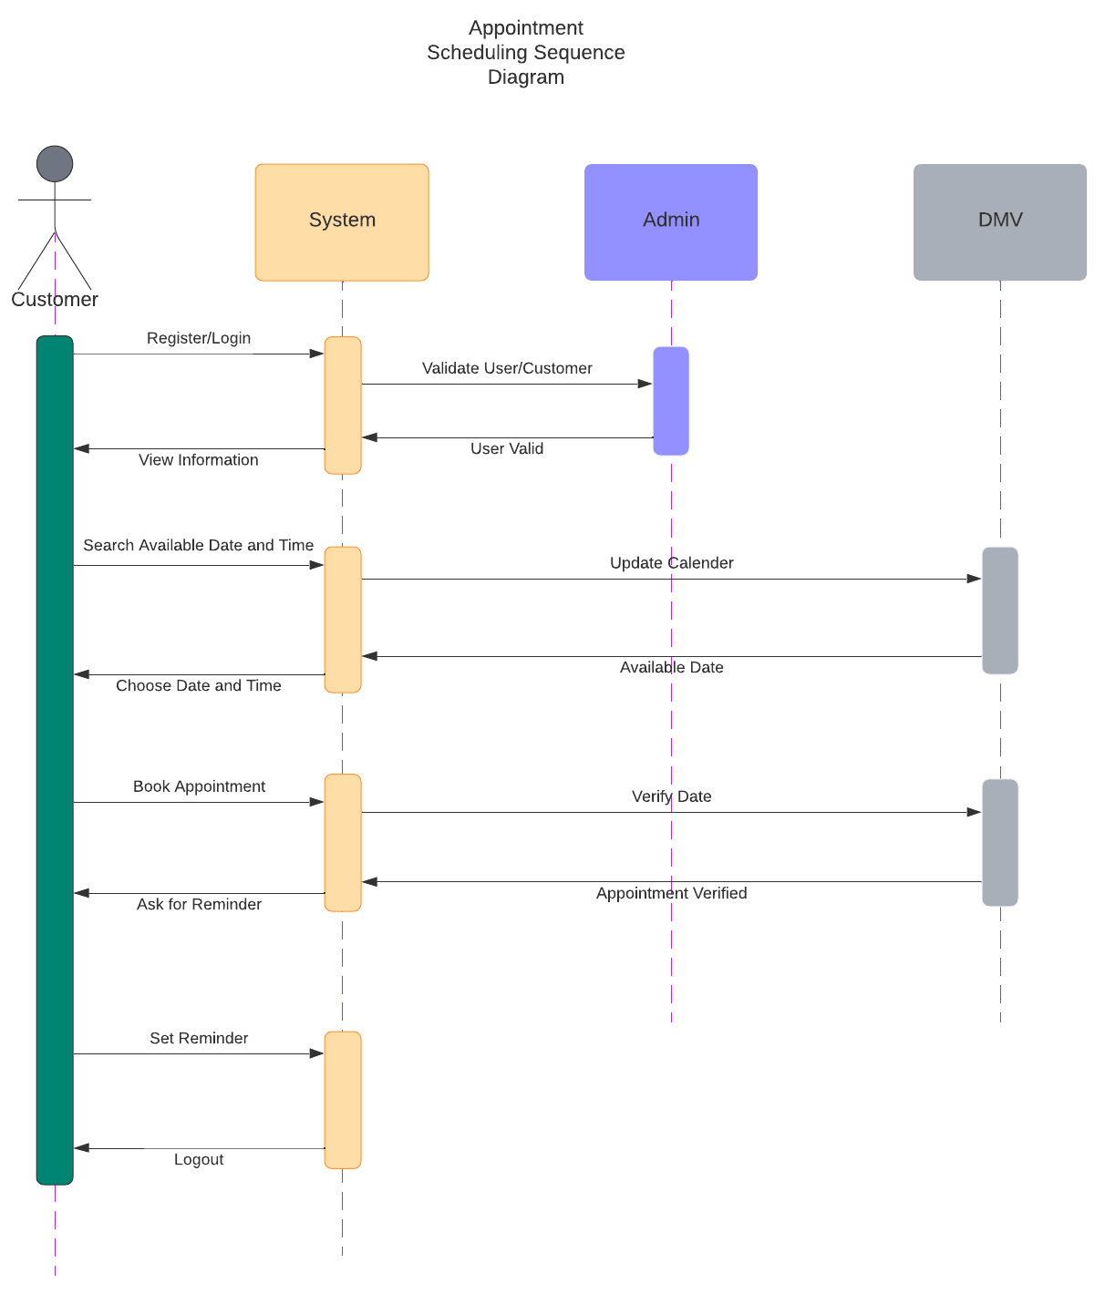

**UML Class Diagram**

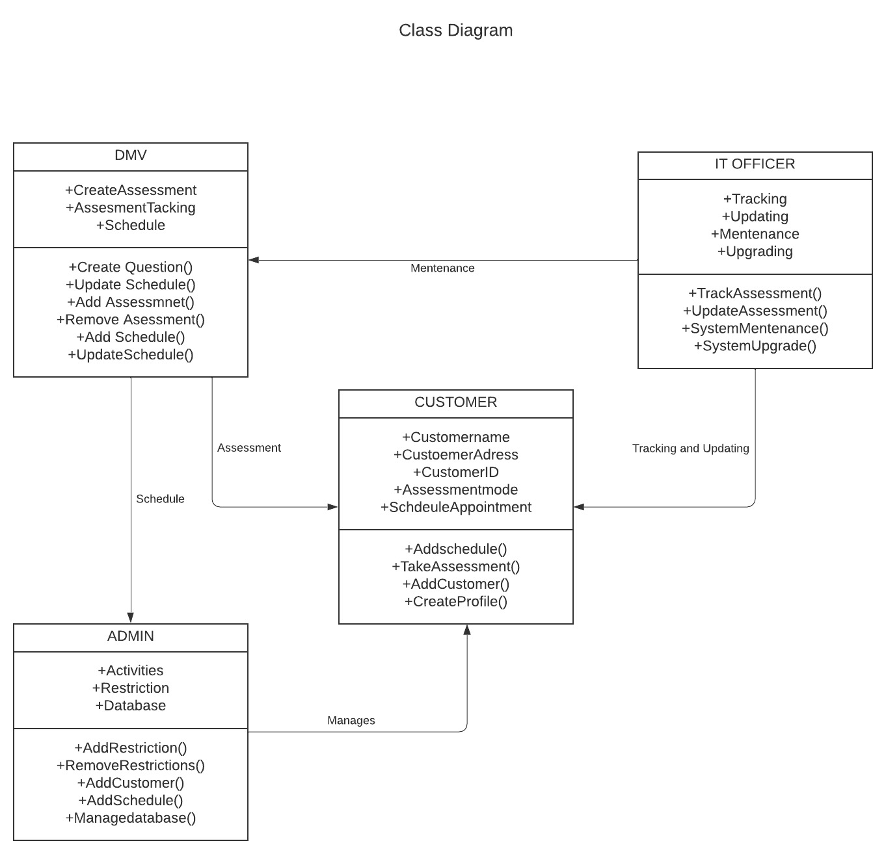

**Technical Requirements**

The UML use case diagram mainly describes the requirements and purposes of the Driver Pass project system. The system will be web based, via website over the cloud. There are 4 different actors (Admin, IT Officer, customer and DMV) included and 7 use cases captured and assigned in the use case diagram. The use case diagram captures all the necessary functionalities and use case. The system will need to be fast enough to allow all of the users to access the website simultaneously without complication and at any time, the system can be updated, and new features should be added.

The system will allow customers to take exams, and specific classes online. The website will allow customers to schedule, change, and cancel on the road training. The system also needs to only allow specific access to certain employees, this allows those employees to make changes, or to improve the system and provide any updates needed. When creating the system, it would be optimal to use object models, process models and UML diagrams in order to provide visualization of the actual system. Need to select an operating platform, one or multiple. Also the proper language we will use to create the actual website.

* The system will validate a user’s credentials when logging in.
* The system will schedule reservations when they are made by the user.
* The system will offer the three different driving packages.
* The system will provide specific access based on the user.
* The system will provide the exams and work the user has already finished.